Name____________________________ input.doc

Match each equation below with its corresponding graph.

a) $f(x)=\frac{2x^{2}−1}{−x^{2}+x+2}$ b) $f(x)=\frac{x^{3}−1}{−x^{2}+x+2}$ c) $f(x)=\frac{2x^{4}−1}{−x^{2}+x+2}$

d) $f(x)=\frac{2x−1}{−x^{2}+x+2}$ e) $f(x)=\frac{x^{5}−1}{−x^{2}+x+2}$ f) $f(x)=\frac{−x^{3}−1}{−x^{2}+x+2}$
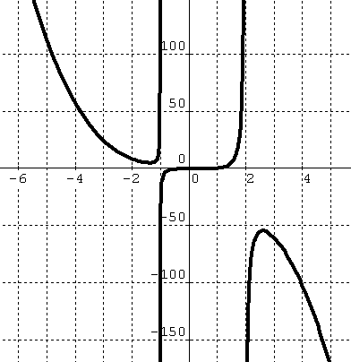
b
e
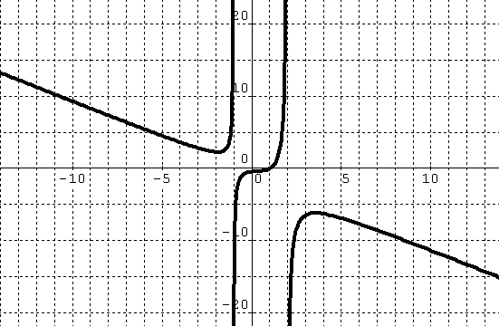

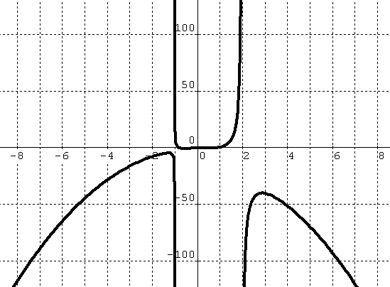
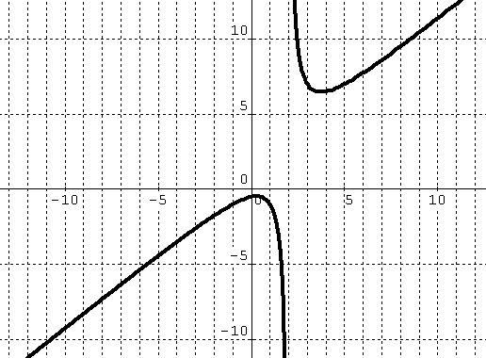
c
f

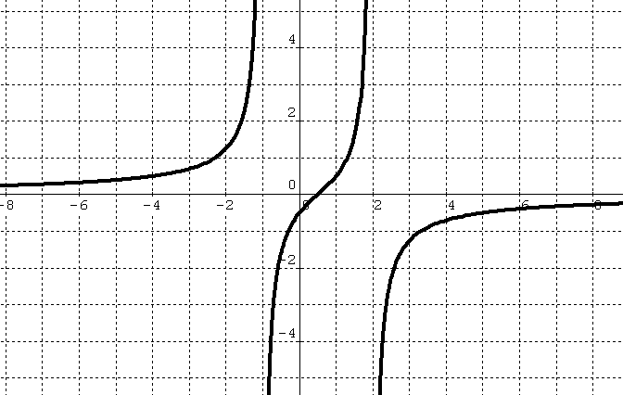
d
a
